

Sprint One

weekly report

ICA DESIGN | Rapid App Development | 01/11/2021

Caspian Maclean, Andrew Williamson, Ivan Ng

8/11/2021

Contents

SPRINT ONE 3

Source Control 3

Project Management 4

Kanban screenshots 4

Meetings and communication 7

Initial Sprint One Meeting - minutes 7

Consultation meetings with Lecturer - minutes 7

Second Sprint One Meeting - minutes 7

Third Sprint One Meeting - minutes 8

Teams chat 8

Teams chat 8

Testing/Validation Plan - Testing Variables 10

Responsiveness 10

Data Validation 10

Analysis 11

CITE business rules for software development 11

CITE Managed Services Quality Assurance 13

Acme Entertainment Pty Ltd development requirements 14

Multiplatform Report - Adaptive vs Responsive Design 16

Responsive Design 16

Adaptive Design 16

What we went for 16

Sprint One Testing 17

Test Methods 17

Test Table 18

Screen Captures 21

References 27

# SPRINT ONE

In this sprint we analysed and implemented making the web app more suitable for multiple devices of different screen sizes.

The result has been uploaded to our local server, to be accessed at <http://192.168.56.102/ICA_Design/>

## Source Control

The project is using GitHub for source control.

The project is located at <https://github.com/cjmaclean/MovieGroupProject>

For sprint one, the development will be done under a branch “sprint-1”

Team members are using two git clients: GitHub desktop, and TortoiseGit

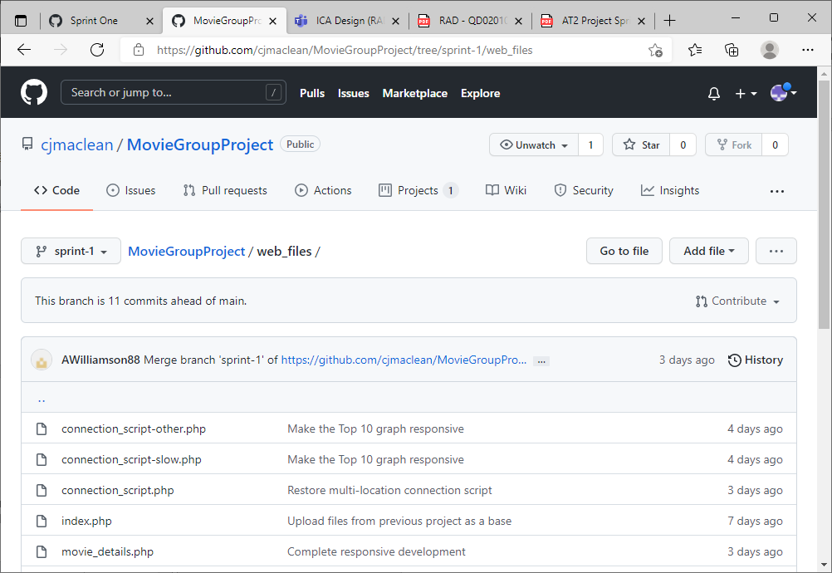

Project GitHub

## Project Management

GitHub’s project Kanban feature will be used for project management. The first Kanban is created in a project called Sprint One inside the repository. The scrum master (Caspian for the first sprint) assigns tasks to the other team members, discussing it in scrum meetings and documenting this on the Kanban board.

### Kanban screenshots

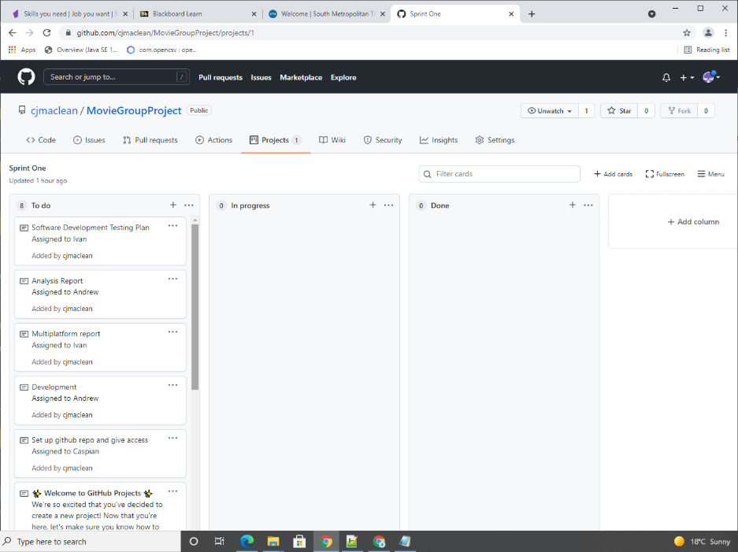

Initial Kanban board with tasks assigned

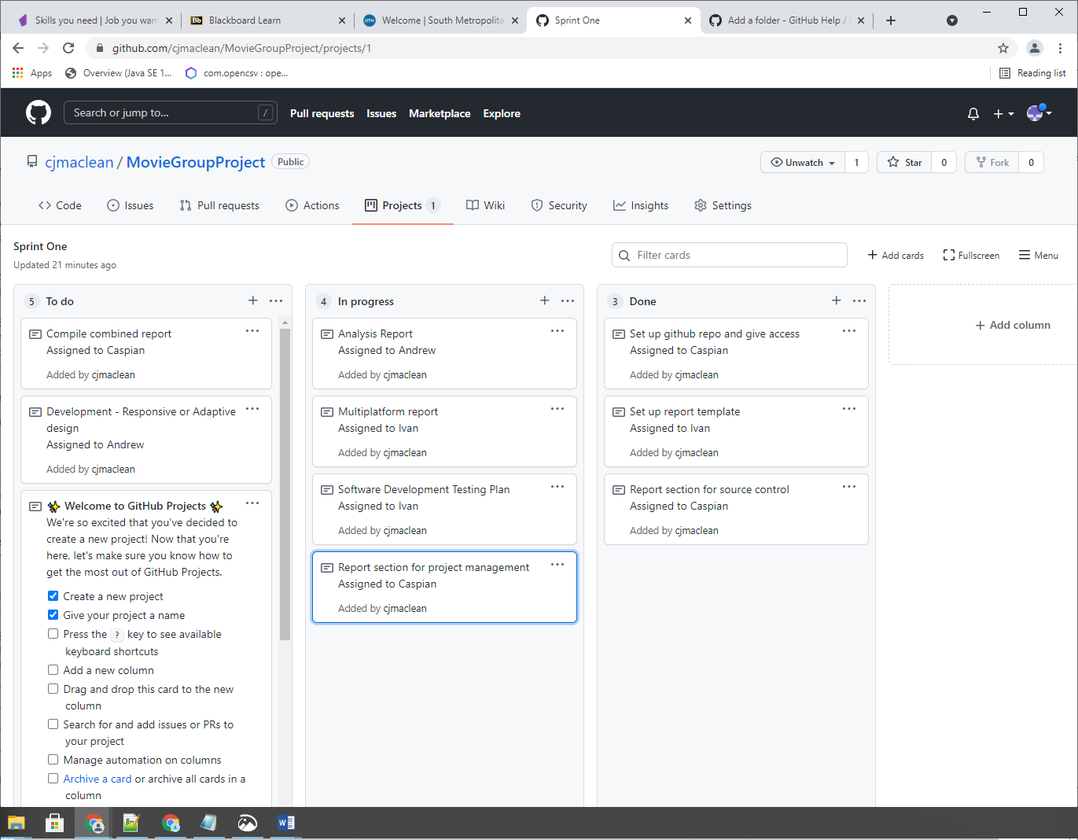

Kanban board later on the first day with some tasks in progress and done

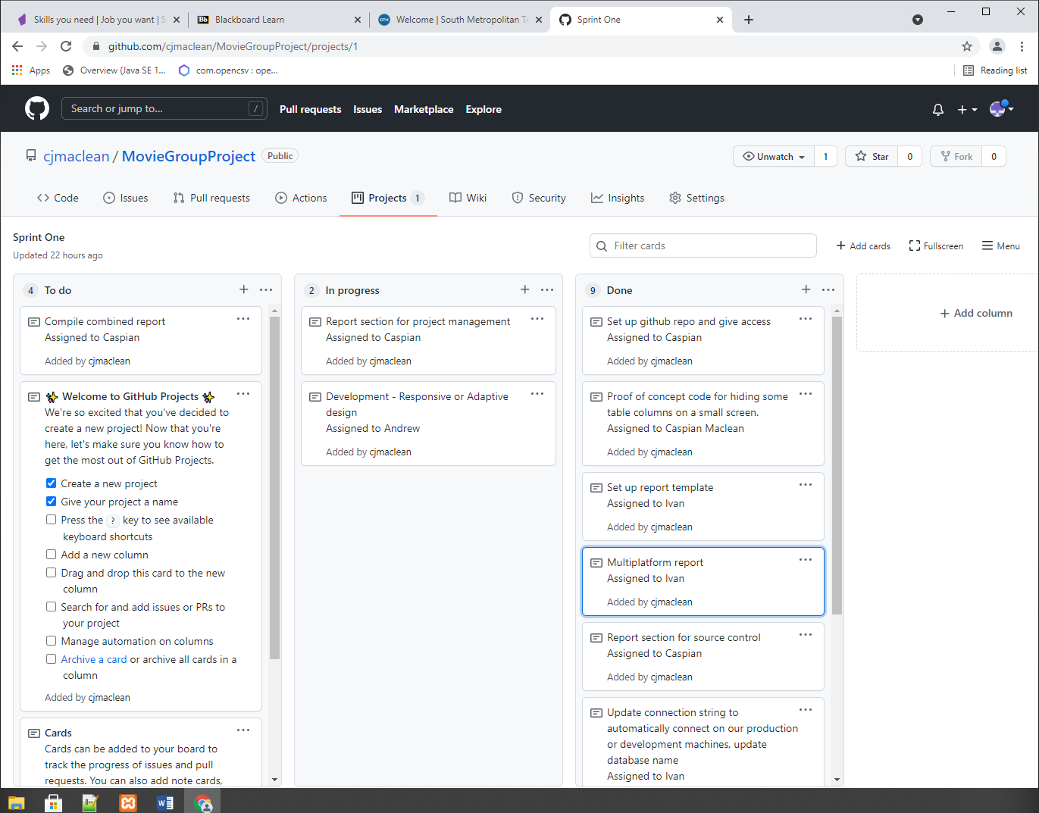

Kanban board Wednesday morning with many tasks complete

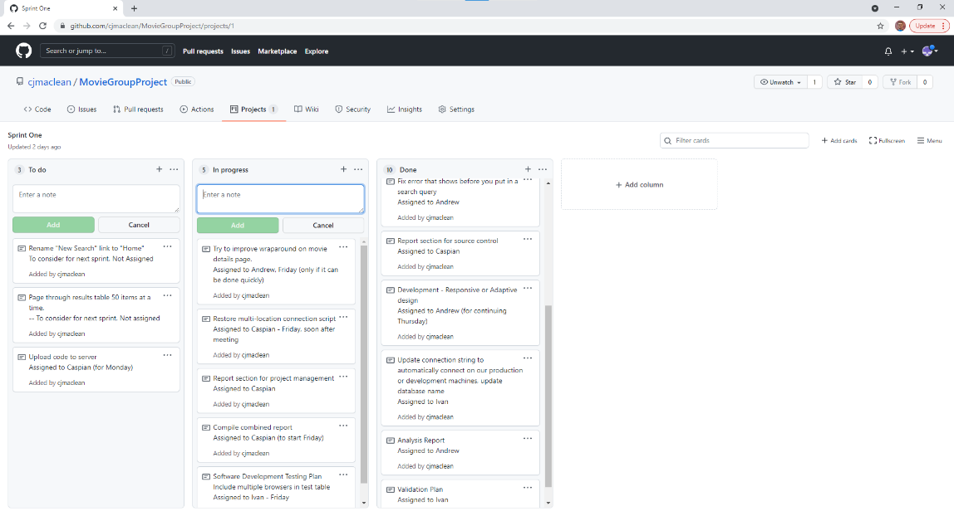

Kanban board after Friday meeting

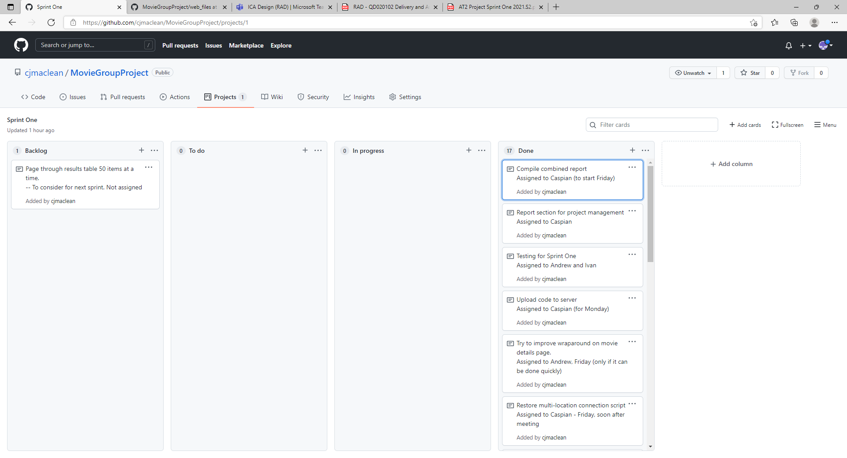

Kanban board after completion on Monday

## Meetings and communication

Meeting minutes and some screenshots from the Teams chat are included below

1/11/2021

### Initial Sprint One Meeting - minutes

* Scrum master is decided as Caspian Maclean for Sprint One
* Caspian to set up GitHub repo and give access.
* Caspian to Set up Kanban project within GitHub repo (Project Management Plan)
* Team name is decided – ICA Design
* Choice of base project – we’ll look at all.
* We will use responsive design so long as that’s consistent with the Multiplatform report.
* Scrum master assigning tasks
* Master template (pick a built-in style) – Ivan.
* Demonstrating our individual projects
* Picking Caspian’s base project.
* We’ll request to use some Bootstrap.
* Bootstrap use is approved.
* Do we need notes for our other meetings? Only a couple per week. Others don’t need notes.
* We well use Teams for meetings.
* Daily updates, we’ll do in text on teams, in the morning. What we did, what we will do today, any impediments.

### Consultation meetings with Lecturer - minutes

* Can we all just edit the same document instead of the scrum master compiling the parts into one? Answer: no.

3/11/2021

### Second Sprint One Meeting - minutes

* 9:00 meeting Friday (voice meeting)
* Ivan, no more tasks yet. Maybe test table? Responsiveness. Multi browsers – Edge and Chrome.
* Have a look at the test stuff. Is it enough?
* Possible putting search results on same page as search query. Ivan to look at that briefly today.
* Andrew working on the Responsive code tomorrow.
* Caspian uploading current code to server, to test.

5/11/2021

### Third Sprint One Meeting - minutes

* Ivan worked on the Testing document. Should be able to do today.
* Caspian just tested the new version created by Andrew briefly. Today and Sunday, working on integrating reports. Also taking meeting notes and updating Kanban
* Commit the connection script that works in multiple locations – Caspian doing today soon after meeting.
* Ivan and Caspian looked at Andrew’s updates to web app – looks good and responsive.
* Andrew did the Responsive code, and fixed error in initial search form.
* Ivan proposed two ideas: show pages of results, e.g. 50 at a time. Rename “New search” to “Home”

For the third meeting we used Teams voice chat

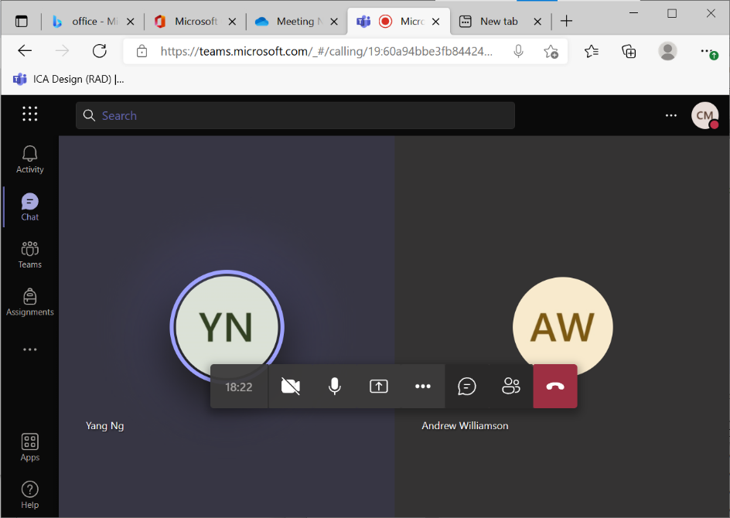

### Teams chat

We also kept in communication with Microsoft Teams

### Teams chat

We also kept in communication with Microsoft Teams

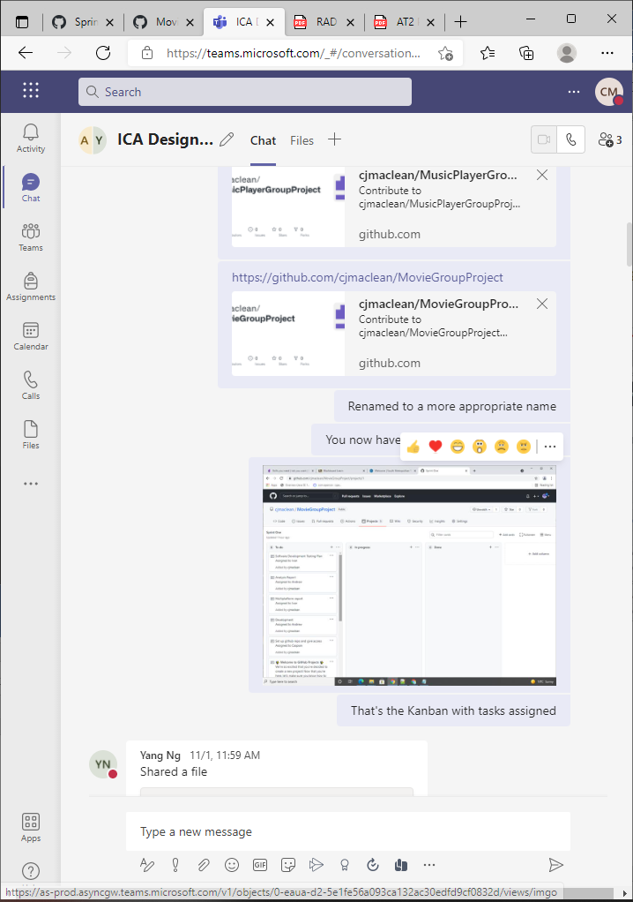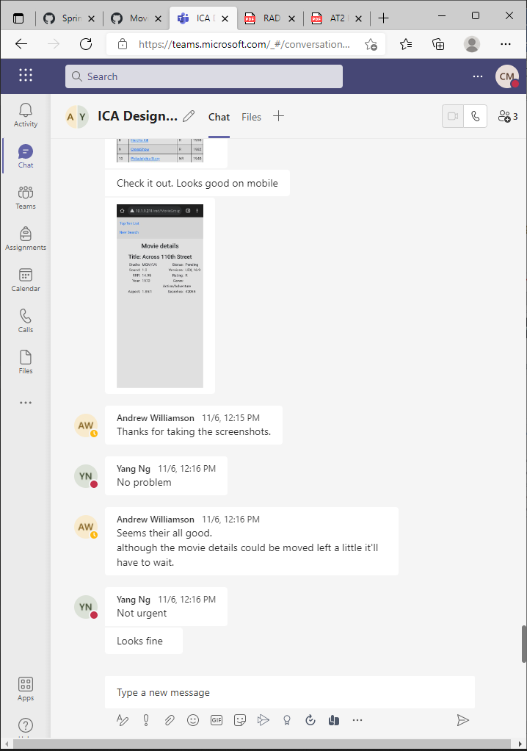

Teams chat

## Testing/Validation Plan - Testing Variables

To validate the website we will be testing our project with the variables below and comparing them with our sprints outcome to hopefully see improvement in design and performance

### Responsiveness

Responsive design is a website that arranges itself based off the width of the screen. A good responsive design is when different width is present different widgets/objects adjust accordingly to fit itself in an ideal arrangement.

For the project we will be making sure that no movie information gets lost and we need to make sure that text are readable in different screen sizes.

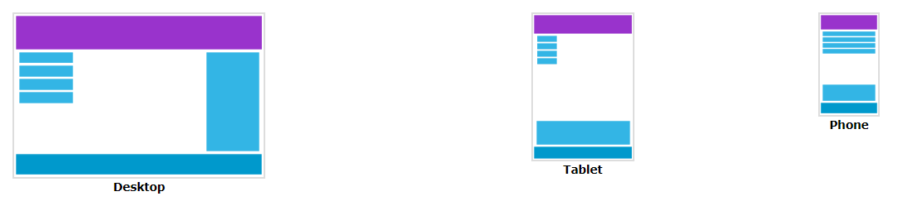

### Data Validation

To ensure that the programs search functionality is working correctly in every iteration we will validate various data types to make sure the outcome is accurate to what we’ve searched for.

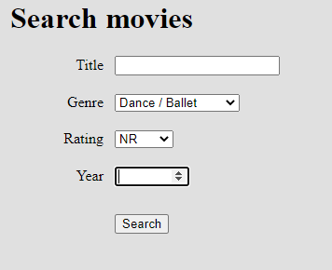

## Analysis

### CITE business rules for software development

#### Coding Standards

The coding standards will reflect the context of the Language and the Clients requirements. In the absence of these criteria CITE developers will default to the industry standard (C# – Microsoft, Java – Oracle)

Coding standards are collections of coding rules, guidelines, and best practices. A coding standards document tells developers how they must write their code. Instead of each developer coding in their own preferred style, they will write all code to the standards outlined in the document. This makes sure that a large project is coded in a consistent style.

#### Common Aspects of Our Coding Standard:

* Naming Conventions
* File Naming and Organization
* Formatting and Indentation
* Comments and Documentation
* Classes, Functions and Interfaces
* Pointer and Reference Usage
* Testing

All systems and projects will be covered by the following ISO Standard(s)

ISO/IEC/IEEE 12207:2017 Systems and software engineering — Software life cycle processes

#### User Interface Development Guidelines

The user experience is the most important part of the product as it can gives the product a competitive advantage by acting as a differentiator. UX design’s main goal is to create solutions that are directly related to the business strategy which will create a holistic and optimized user experience for the user. The following guidelines should be considered a part of the software development.

* **Visibility of system status**. Users should always be informed of system operations with easy to understand and highly visible status displayed on the screen within a reasonable amount of time.
* **Match between system and the real world**. Designers should endeavour to mirror the language and concepts users would find in the real world based on who their target users are. Presenting information in logical order and piggybacking on user’s expectations derived from their real-world experiences will reduce cognitive strain and make systems easier to use.
* **User control and freedom**. Offer users a digital space where backward steps are possible, including undoing and redoing previous actions.
* **Consistency and standards**. Interface designers should ensure that both the graphic elements and terminology are maintained across similar platforms. For example, an icon that represents one category or concept should not represent a different concept when used on a different screen.
* **Error prevention**. Whenever possible, [design systems](https://www.interaction-design.org/literature/topics/design-systems) so that potential errors are kept to a minimum. Users do not like being called upon to detect and remedy problems, which may on occasion be beyond their level of expertise. Eliminating or flagging actions that may result in errors are two possible means of achieving error prevention.
* **Recognition rather than recall.**Minimize [cognitive load](https://www.interaction-design.org/literature/topics/cognitive-load) by maintaining task-relevant information within the display while users explore the interface. Human attention is limited and we are only capable of maintaining around five items in our short-term memory at one time. Due to the limitations of short-term memory, designers should ensure users can simply employ recognition instead of recalling information across parts of the dialogue. Recognizing something is always easier than recall because recognition involves perceiving cues that help us reach into our vast memory and allowing relevant information to surface. For example, we often find the format of multiple choice questions easier than short answer questions on a [test](https://www.interaction-design.org/literature/topics/test) because it only requires us to recognize the answer rather than recall it from our memory.
* **Flexibility and efficiency of use**. With increased use comes the demand for less interactions that allow faster [navigation](https://www.interaction-design.org/literature/topics/navigation-1). This can be achieved by using abbreviations, function keys, hidden commands and macro facilities. Users should be able to customize or tailor the interface to suit their needs so that frequent actions can be achieved through more convenient means.
* **Aesthetic and minimalist design**. Keep clutter to a minimum. All unnecessary information competes for the user’s limited attentional resources, which could inhibit user’s memory retrieval of relevant information. Therefore, the display must be reduced to only the necessary components for the current tasks, whilst providing clearly visible and unambiguous means of navigating to other content.
* **Help users recognize, diagnose and recover from errors**. Designers should assume users are unable to understand technical terminology, therefore, error messages should almost always be expressed in plain language to ensure nothing gets lost in translation.
* **Help and documentation**. Ideally, we want users to navigate the system without having to resort to documentation. However, depending on the type of solution, documentation may be necessary. When users require help, ensure it is easily located, specific to the task at hand and worded in a way that will guide them through the necessary steps towards a solution to the issue they are facing.

(CITE MANAGED SERVICES, 2021)

### CITE Managed Services Quality Assurance

CITE Managed Services has implemented a Quality Management System (QMS) comprising a complex set of engineering and managerial activities that ensure bespoke quality of delivered software throughout the entire workflow.

#### Quality Management Systems Tasks and Objectives

* Elaboration and implementation of procedures and regulations for software development process based on industry standards and best practices;
* Product lifecycle monitoring to ensure compliance with established processes and guidelines
* Product quality verification and validation to ensure that it complies with clients’ business needs and expectations;
* Establishment of an effective collaboration between all project team members.

#### Quality Planning

CITE Managed Services puts together quality plans that govern the applicable set of standards, regulations, procedures, guidelines and tools during the development lifecycle in each project.

#### Quality Assurance

We have established processes that evaluate project performance and aim to assure that quality standards are being followed and that the deliverables comply with customer requirements.

#### Quality Control

We measure performance trends to identify defective pieces of code, verify that deliverables are of high quality and that they are complete and correct.

#### Independent QA Department

CITE Managed Services QA department is an independent structural subdivision. Our QA team consists of skilled QA engineers who get involved in projects on a dedicated or an on-demand basis. The allocation of QA engineers depends on project size and complexity: they can be easily reallocated from one project to another upon necessity. Such flexibility allows us to optimize efforts and, thus, the overall project budget. Our QA Department is responsible for:

* Full-cycle QA Testing
* Document and Code Reviews
* Defect Tracking
* Configuration Management
* Process Monitoring
* Risk Management

#### QA that is Weaved into the Development Lifecycle

CITE Managed Services performs quality assurance throughout the entire software development lifecycle with QA team members being involved at all stages. A Lead QA specialist is assigned at the commencement of each project and is involved into initial business analysis and requirements specification. Such a simultaneous interaction of our development and QA teams provides for a better understanding of the project scope and the client’s business objectives. A typical QA lifecycle at CITE Managed Services includes the following phases:

1. INITIATION AND PLANNING – Project specification analysis, test plan elaboration and team assignment
2. FIRST REVIEW – Initial testing of first development deliverables, refining the test plan and test items (if necessary).
3. ITERATION AUDITS – Ongoing testing of intermediate iterations builds
4. FINAL VERIFICATION AND VALIDATION – Final product testing to ensure bespoke quality and readiness for deployment.

We utilize the full spectrum of test types as to ensure that your project enjoys in-depth quality assurance:

* Functional and Regression Testing;
* GUI and Usability Testing;
* Accessibility Testing;
* Compatibility Testing;
* Performance Testing;
* Installation / Configuration Testing;
* System / Integration Testing;
* Security Testing;
* Internationalization / Localization Testing;
* User Acceptance Testing (UAT).

(CITE MANAGED SERVICES, 2021)

### Acme Entertainment Pty Ltd development requirements

* Multi-Platform Report on the merits of the two design options currently used; adaptive and responsive.
* Choose the best option and rework the prototype.
* Modified version is to be presented at the Sprint One assessment point by the first Scrum Master.
* The development or migration of the movie database can be hosted on the cloud or suitable local server.
* Ensure your Lecturer is advised on this decision.
* Conduct and record suitable testing of the completed sprint one development, include this information in the Testing Plan.

## Multiplatform Report - Adaptive vs Responsive Design

### Responsive Design

#### Definition

Responsive design is a style in designing a website for the purpose of having elements of websites fit in available space based of the width of the browser. When the browser changes the width content dynamically change in size or rearrange itself to fit in the website.

#### Pros and Cons

|  |  |
| --- | --- |
| **Pros** | **Con** |
| Uniform and seamless | Longer mobile load times |
| SEO friendly | Elements can move around |
| Often easier to implement with many already available CSS frameworks | Ads can get lost on screen |

### Adaptive Design

#### Definition

Adaptive design is when a website has multiple fixed layout sizes. When the browser opens it will choose which layout is appropriate for the space that’s available. When resizing the browser, the design won’t change until it reaches another layouts size.

#### Pros and Cons

|  |  |
| --- | --- |
| **Pros** | **Con** |
| Allows designers to design the best UI/UX for the appropriate device | Can be labor intensive as there’s generally 3 different design per page |
| Increase in load times | Hard to maintain |
| Advertising monetization | Because it’s labor intensive it is also expensive |

### What we went for

As a team we’ve decided for the movie project to go with a responsive design approach. Because of the short amount of time we are given to complete this project it only made sense to go with responsive design as it’s less labor intensive.

## Sprint One Testing

### Test Methods

#### Regression Testing

One of the methods of testing we’ll be using for this project is regression testing. Because we’ll be implementing a lot of features, we’ll need to make sure we test thoroughly to make sure any new feature won’t have broken any previous feature.

#### End to End Testing

Another method we’ll be using will be end to end testing or e2e for short. E2e is a method used to test the functionality and performance of the application by simulating user actions and user experience.

### Test Table

|  |  |  |  |  |  |
| --- | --- | --- | --- | --- | --- |
| **Test #** | **Browser** | **Test Description** | **Expected Result** | **Actual Result** | **Result Screenshot** |
| 1 | Chrome | Search movie title | Table of movie search results | As Expected | Ref Figure 1 |
| 2 | Chrome | Search movie title and genre | Table of movie search results | As Expected | Ref Figure 2 |
| 3 | Chrome | Test responsiveness with mobile resolution on search page | Shows page responsiveness with necessary information | As Expected | Ref Figure 3 |
| 4 | Chrome | Test responsiveness with tablet resolution on search page | Shows page responsiveness with necessary information | As Expected | Ref Figure 4 |
| 5 | Chrome | Test responsiveness with desktop on search page | Shows page responsiveness with necessary information | As Expected | Ref Figure 5 |
| 6 | Chrome | Test responsiveness with mobile resolution on Top 10 page | Shows page responsiveness with necessary information | As Expected | Ref Figure 6 |
| 7 | Chrome | Test responsiveness with tablet resolution on top 10 page | Shows page responsiveness with necessary information | As Expected | Ref Figure 7 |
| 8 | Chrome | Test responsiveness with desktop on top 10 page | Shows page responsiveness with necessary information | As Expected | Ref Figure 8 |
| 9 | Chrome | Test responsiveness with mobile resolution on movie detail page | Shows page responsiveness with necessary information | As Expected | Ref Figure 9 |
| 10 | Chrome | Test responsiveness with tablet resolution on movie detail page | Shows page responsiveness with necessary information | As Expected | Ref Figure 10 |
| 11 | Chrome | Test responsiveness with desktop on movie detail page | Shows page responsiveness with necessary information | As Expected | Ref Figure 11 |
| 12 | Edge | Search movie title | Table of movie search results | As Expected | Ref Figure 12 |
| 13 | Edge | Search movie title and genre | Table of movie search results | As Expected | Ref Figure 13 |
| 14 | Edge | Test responsiveness with mobile resolution on search page | Shows page responsiveness with necessary information | As Expected | Ref Figure 14 |
| 15 | Edge | Test responsiveness with tablet resolution on search page | Shows page responsiveness with necessary information | As Expected | Ref Figure 15 |
| 16 | Edge | Test responsiveness with desktop on search page | Shows page responsiveness with necessary information | As Expected | Ref Figure 16 |
| 17 | Edge | Test responsiveness with mobile resolution on Top 10 page | Shows page responsiveness with necessary information | As Expected | Ref Figure 17 |
| 18 | Edge | Test responsiveness with tablet resolution on top 10 page | Shows page responsiveness with necessary information | As Expected | Ref Figure 18 |
| 19 | Edge | Test responsiveness with desktop on top 10 page | Shows page responsiveness with necessary information | As Expected | Ref Figure 19 |
| 20 | Edge | Test responsiveness with mobile resolution on movie detail page | Shows page responsiveness with necessary information | As Expected | Ref Figure 20 |
| 21 | Edge | Test responsiveness with tablet resolution on movie detail page | Shows page responsiveness with necessary information | As Expected | Ref Figure 21 |
| 22 | Edge | Test responsiveness with desktop on movie detail page | Shows page responsiveness with necessary information | As Expected | Ref Figure 22 |

### Screen Captures

|  |  |  |
| --- | --- | --- |
|  |  |  |
|  |  |  |
|  |  |  |
|  |  |  |
|  |  |  |
|  |  |  |
|  |  |  |
|  |  |  |
|  |  |  |
|  |  |  |
|  |  |  |
|  |  |  |
|  |  |  |
|  |  |  |
|  |  |  |
|  |  |  |
|  |  |  |
|  |  |  |
|  |  |  |
|  |  |  |
|  |  |  |
|  |  |  |

# References

CITE MANAGED SERVICES. (2021). *CODING POLICIES AND STANDARDS*. Retrieved November 01, 2021, from citems: https://www.citems.com.au/services/application-development/standards/

CITE MANAGED SERVICES. (2021). *QUALITY MANAGEMENT*. Retrieved November 01, 2021, from citems: https://www.citems.com.au/services/application-development/quality-management/